On First Page only provide the following information
Type or paste the title of your article here
Author Names separated by , ^{1*}
¹Department, University, City, Country
Provide full correspondence details here including e-mail for the corresponding author
*E-mail of the corresponding author:
Note: The affiliation should be the institution where the work was conducted. If the present address of an author differs from that at which the work was done, indicate with a symbol and give the Present Address under Author Information.

Repeat the title of your article here
(Don’t mention Author Names)
Note: All text should be written with the line spacing of 1.0 and justified.
Abstract: An abstract is a single paragraph, without indentation, that summarizes the key points of the manuscript in 150 to 250 words.
Type or paste your abstract here as prescribed by the journal’s instructions for authors. Type or paste your abstract here as prescribed by the journal’s instructions for authors. Type or paste your abstract here as prescribed by the journal’s instructions for authors. Type or paste your abstract here.
Keywords: word, another word, lower case except names
Subject classification codes: include these here if the journal requires them

Main Body of the Text (Introduction….Appendix)

Heading 1(use this style for level one headings)
In the manufacturing sector today, human capital is still essential for most factories to carry out a variety of manual operations, in spite of the rapid advancement of automation technology and robotics. With the futuristic vision of “unmanned manufacturing”, Deen(1993) predicted that it will be forbiddingly expensive.

For bullets, numbering and quotation follow APA Manual 6th Edition.

Heading 2(use this style for level two headings)
Heading 3(use this style for level three headings)
Note: Prior to peer review, avoid identifying any of the authors in the text.

Tables and Figures
Give every table a brief but clear and explanatory title. Please see APA Manual 6th edition.
Table Example:

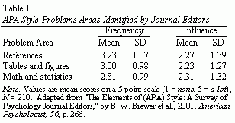

Figure Example:
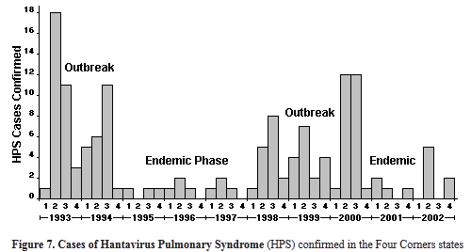

References
Take note of the "hanging indent" style for references with 1.0 line spacing. Follow APA Manual 6th edition.
Note: References of bibliographic materials are not required; only provide in-text citation references.

Appendix

This is optional section which may not be included in the body of the article.

About Author(s)
Provide short biographical notes on all contributors.

